TOPIC 6 : BACKTRACKING
NAME: LAKSHMI DEVI.J
REG.NO: 192524300

1. Discuss the importance of visualizing the solutions of the N-Queens Problem to understand the placement of queens better. Use a graphical representation to show how queens are placed on the board for different values of N. Explain how visual tools can help in debugging the algorithm and gaining insights into the problem's complexity. Provide examples of visual representations for N = 4, N = 5, and N = 8, showing different valid solutions.
Aim
To visualize valid placements of N queens on an N×N chessboard and understand how backtracking works.
Algorithm
- Start from the first row.
- Try placing a queen in each column.
- Check whether the position is safe.
- If safe, place the queen and move to the next row.
- If no position is possible, backtrack.
- Display the board when all queens are placed.
Python Program
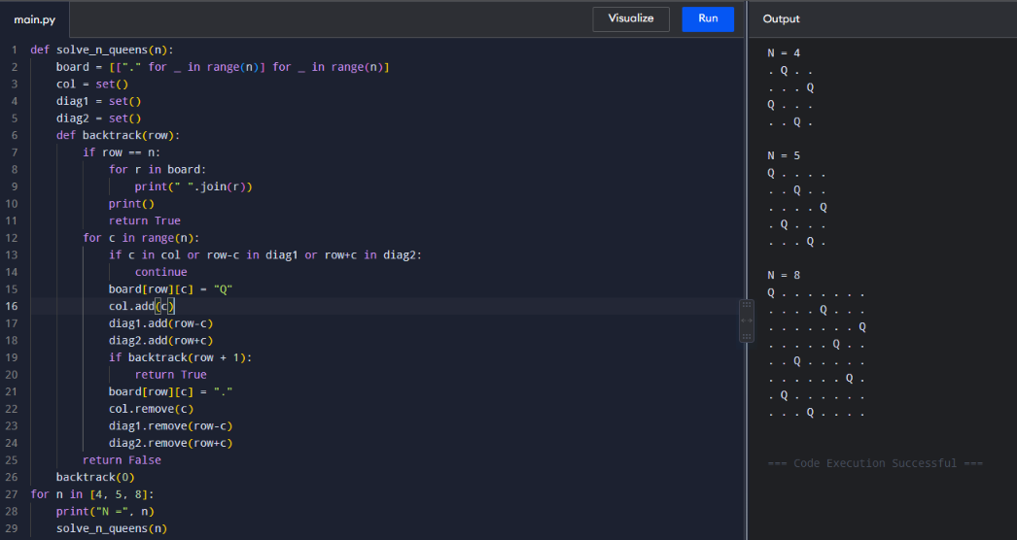
Time:O(N!)
Space: O(N²)

2. Discuss the generalization of the N-Queens Problem to other board sizes and shapes, such as rectangular boards or boards with obstacles. Explain how the algorithm can be adapted to handle these variations and the additional constraints they introduce. Provide examples of solving generalized N-Queens Problems for different board configurations, such as an 8×10 board, a 5×5 board with obstacles, and a 6×6 board with restricted positions.
8×10 Board:
Aim
To solve N-Queens on rectangular boards and boards with obstacles/restricted positions.
Algorithm
- Represent the board using rows and columns.
- Try each allowed column for every row.
- Check column and diagonal conflicts.
- Ignore obstacle/restricted positions.
- Backtrack when no valid position exists.
Python Program – 8×10 Board
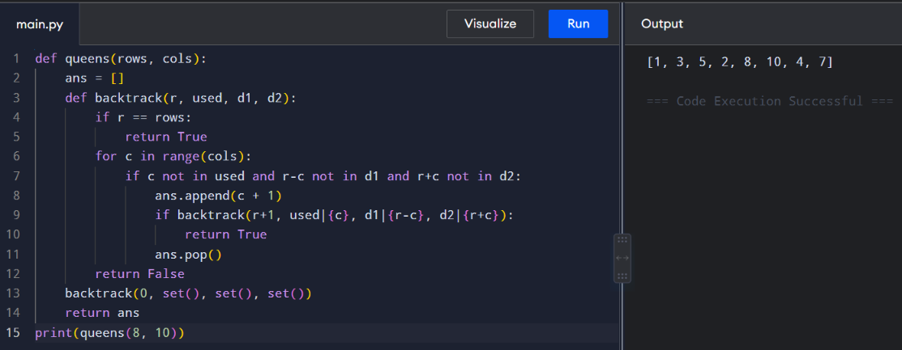
5×5 Board with Obstacles
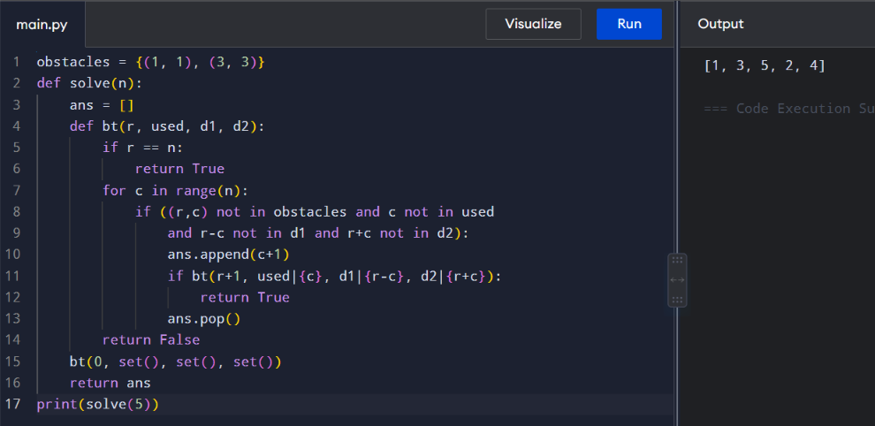
Time: O(N!) approximately
Space: O(N)

3. Write a program to solve a Sudoku puzzle by filling the empty cells. A sudoku solution must satisfy all of the following rules:Each of the digits 1-9 must occur exactly once in each row.Each of the digits 1-9 must occur exactly once in each column.Each of the digits 1-9 must occur exactly once in each of the 9 3x3 sub-boxes of the grid. The '.' character indicates empty cells.
Aim
To solve a 9×9 Sudoku puzzle using backtracking.
Algorithm
- Find an empty cell.
- Try digits 1–9.
- Check row, column and 3×3 box.
- Place a valid digit.
- Recursively solve the remaining cells.
- Backtrack if the choice is invalid.
Python Program
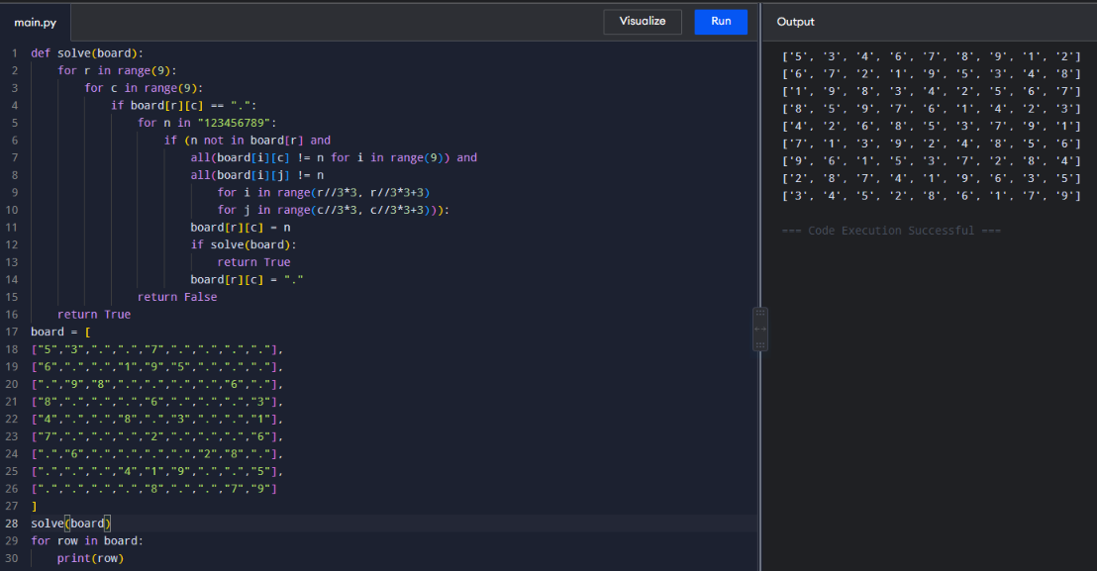
Time: O(9^E), E = empty cells
Space: O(E)
4. You are given an integer array nums and an integer target. You want to build an expression out of nums by adding one of the symbols '+' and '-' before each integer in nums and then concatenate all the integers. For example, if nums = [2, 1], you can add a '+' before 2 and a '-' before 1 and concatenate them to build the expression "+2-1" Return the number of different expressions that you can build, which evaluates to target.
Aim
To find the number of expressions formed using + and - that produce the target value.
Algorithm
- Start from index 0 and sum 0.
- Choose +nums[i].
- Choose -nums[i].
- Recursively process all elements.
- Count when the final sum equals target.
Python Program
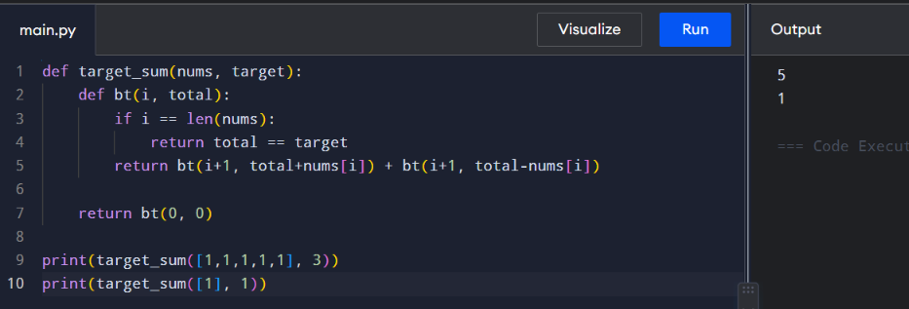
Time: O(2^N)
Space: O(N)
5. Given an array of integers arr, find the sum of min(b), where b ranges over every (contiguous) subarray of arr. Since the answer may be large, return the answer modulo 109 + 7.
Aim
To find the sum of minimum elements of all contiguous subarrays.
Algorithm
- Start from every index.
- Extend the subarray one element at a time.
- Maintain the minimum.
- Add the minimum to the answer.
- Return answer modulo 10⁹+7.
Python Program
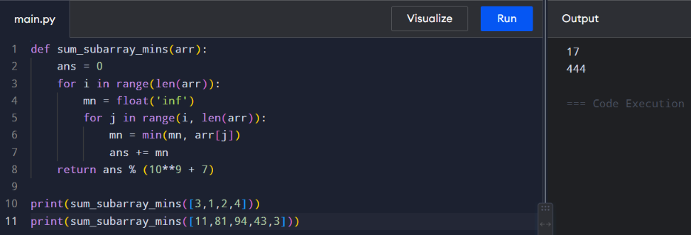
Time: O(N²)
Space: O(1)

6. Given an array of distinct integers candidates and a target integer target, return a list of all unique combinations of candidates where the chosen numbers sum to target. You may return the combinations in any order. The same number may be chosen from candidates an unlimited number of times. Two combinations are unique if the frequency of at least one of the chosen numbers is different.The test cases are generated such that the number of unique combinations that sum up to target is less than 150 combinations for the given input.
Aim
To find all unique combinations whose sum equals the target. Each candidate can be used multiple times.
Algorithm
- Sort candidates.
- Choose a candidate.
- Add it to the current combination.
- Recursively continue from the same index.
- Backtrack when sum exceeds target.
Python Program
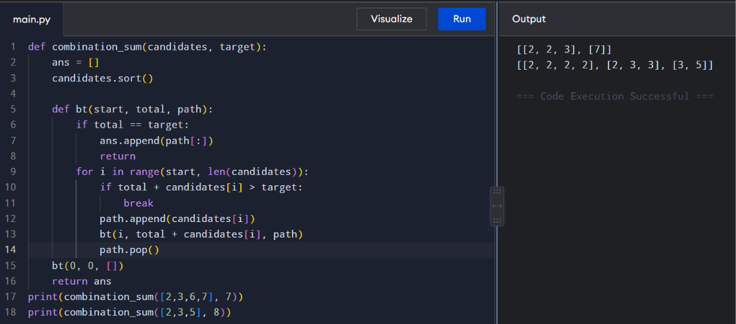
Time: O(N^(T/M)) approximately
Space: O(T/M)

7. Given a collection of candidate numbers (candidates) and a target number (target), find all unique combinations in candidates where the candidate numbers sum to target. Each number in candidates may only be used once in the combination. The solution set must not contain duplicate combinations.
Aim
To find unique combinations whose sum equals target, where each number can be used only once.
Algorithm
- Sort the array.
- Select an element.
- Skip duplicate elements at the same recursion level.
- Recursively find remaining combinations.
- Backtrack.
Python Program
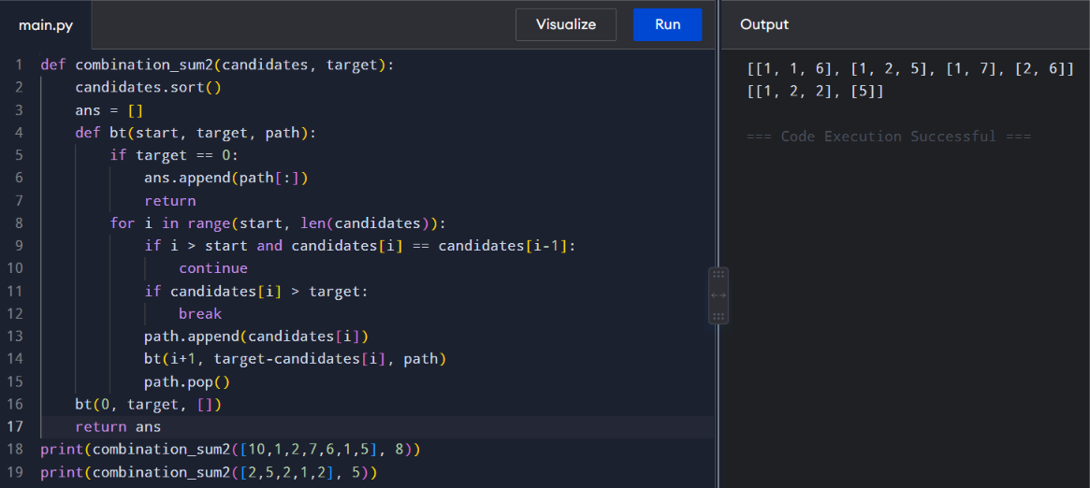
Time: O(2^N)
Space: O(N)

8. Given an array nums of distinct integers, return all the possible permutations. You can return the answer in any order.
Aim
To generate all possible permutations of distinct integers.
Algorithm
- Select an unused element.
- Add it to the current permutation.
- Recursively select the next element.
- Backtrack after completing each permutation.
Python Program
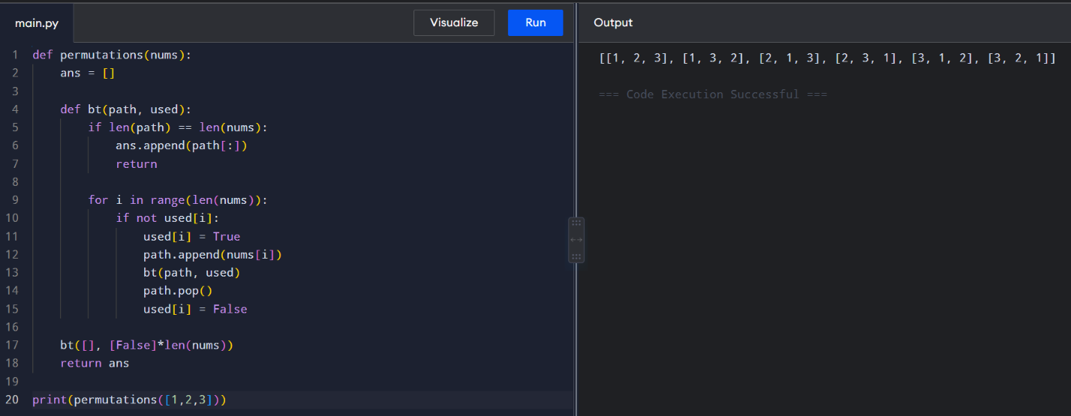
Time: O(N × N!)
Space: O(N)

9. Given a collection of numbers, nums, that might contain duplicates, return all possible unique permutations in any order.
Aim
To generate all unique permutations when duplicate numbers are present.
Algorithm
- Sort the array.
- Select unused elements.
- Skip duplicate elements at the same recursion level.
- Continue recursively.
- Backtrack.
Python Program
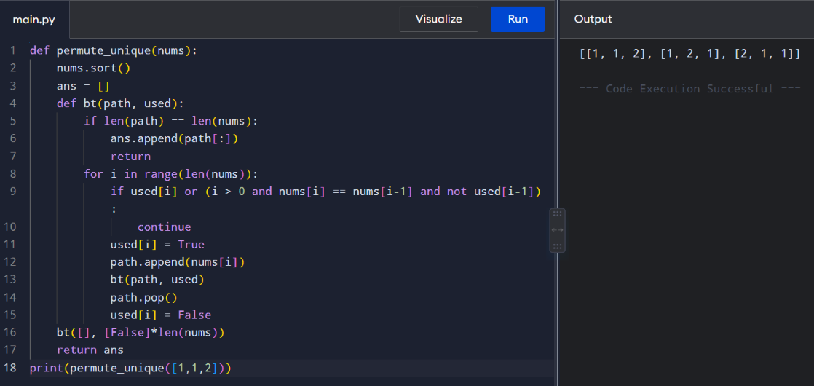
Time: O(N × N!)
Space: O(N)

10. You and your friends are assigned the task of coloring a map with a limited number of colors. The map is represented as a list of regions and their adjacency relationships. The rules are as follows: At each step, you can choose any uncolored region and color it with any available color. Your friend Alice follows the same strategy immediately after you, and then your friend Bob follows suit. You want to maximize the number of regions you personally color. Write a function that takes the map's adjacency list representation and returns the maximum number of regions you can color before all regions are colored. Write a program to implement the Graph coloring technique for an undirected graph. Implement an algorithm with minimum number of colors. edges = [(0, 1), (1, 2), (2, 3), (3, 0), (0, 2)] No. of vertices, n = 4
Aim
To color an undirected graph using the minimum number of colors without assigning the same color to adjacent vertices.
Algorithm
- Select an uncolored vertex.
- Try each available color.
- Check adjacent vertices.
- Assign a valid color.
- Backtrack if no color is possible.
- Find the minimum number of colors.
Python Program
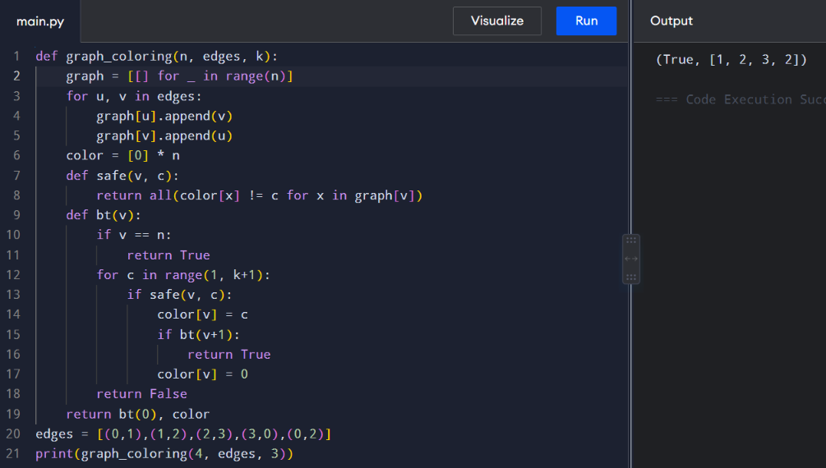
Time: O(K^N)
Space: O(N)
11. You are given an undirected graph represented by a list of edges and the number of vertices n. Your task is to determine if there exists a Hamiltonian cycle in the graph. A Hamiltonian cycle is a cycle that visits each vertex exactly once and returns to the starting vertex. Write a function that takes the list of edges and the number of vertices as input and returns true if there exists a Hamiltonian cycle in the graph, otherwise return false. Example: Given edges = [(0, 1), (1, 2), (2, 3), (3, 0), (0, 2), (2, 4), (4, 0)] and n = 5
Aim
To determine whether an undirected graph contains a Hamiltonian cycle.
Algorithm
- Start from vertex 0.
- Select an unvisited adjacent vertex.
- Continue until all vertices are visited.
- Check whether the last vertex connects to the first.
- Backtrack if necessary.
Python Program
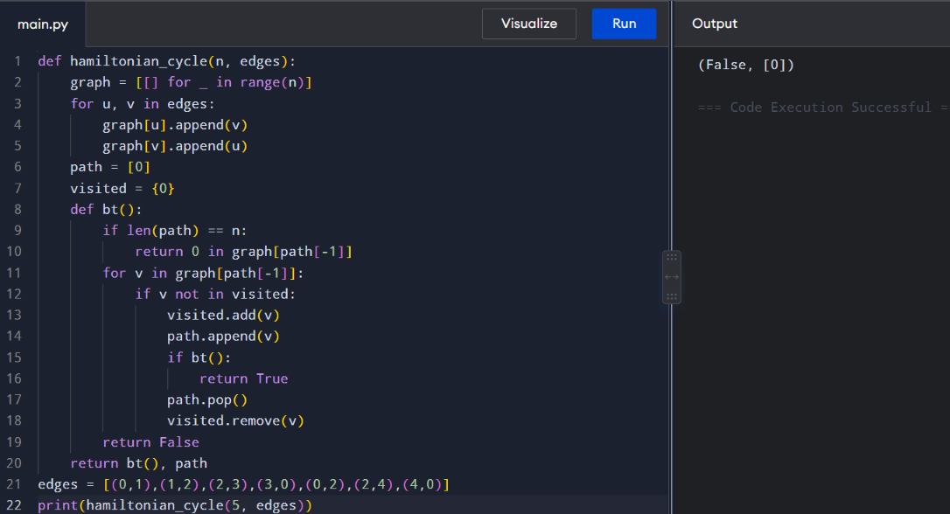
Time: O(N!)
Space: O(N)

12. You are given an undirected graph represented by a list of edges and the number of vertices n. Your task is to determine if there exists a Hamiltonian cycle in the graph. A Hamiltonian cycle is a cycle that visits each vertex exactly once and returns to the starting vertex. Write a function that takes the list of edges and the number of vertices as input and returns true if there exists a Hamiltonian cycle in the graph, otherwise return false. Example:edges = [(0, 1), (1, 2), (2, 3), (3, 0), (0, 2)] and n = 4
Aim
To determine whether a graph contains a Hamiltonian cycle.
Algorithm
Same as Q12:
- Start from vertex 0.
- Select unvisited adjacent vertices.
- Visit every vertex once.
- Check connection back to vertex 0.
- Backtrack when necessary.
Python Program
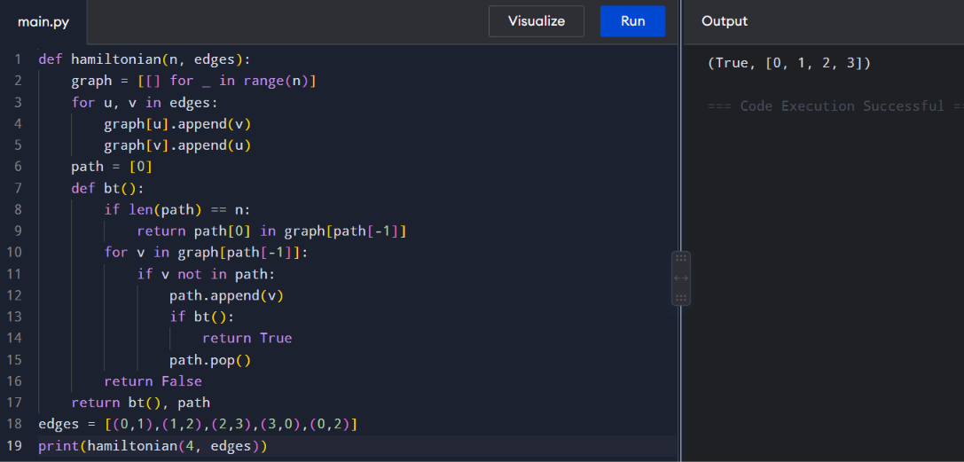
Time: O(N!)
Space: O(N)

13. You are tasked with designing an efficient coading to generate all subsets of a given set S containing n elements. Each subset should be outputted in lexicographical order. Return a list of lists where each inner list is a subset of the given set. Additionally, find out how your coading handles duplicate elements in S. A = [1, 2, 3] The subsets of [1, 2, 3] are: [], [1], [2], [3], [1, 2], [1, 3], [2, 3], [1, 2, 3]
Aim
To generate all subsets of a set using backtracking.
Algorithm
- Start with an empty subset.
- At each element, choose or skip it.
- Store every generated subset.
- Sort the result lexicographically.
- Remove duplicates if required.
Python Program
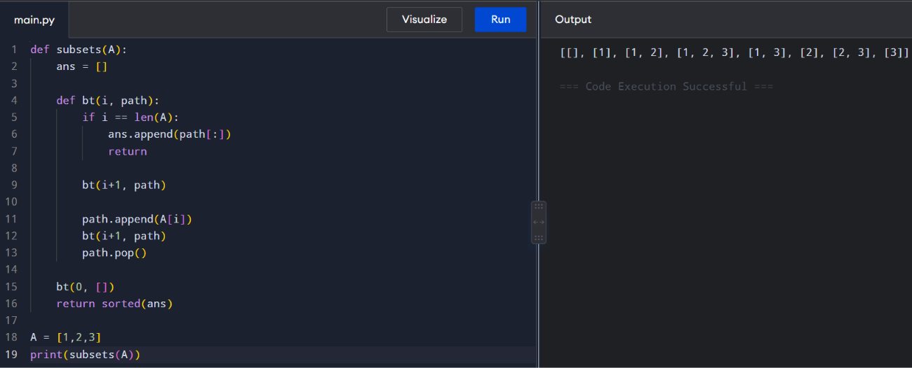
Time: O(2^N)
Space: O(N)

14. Write a program to implement the concept of subset generation. Given a set of unique integers and a specific integer 3, generate all subsets that contain the element 3. Return a list of lists where each inner list is a subset containing the element 3 E = [2, 3, 4, 5], x = 3, The subsets containing 3 : [3], [2, 3], [3, 4], [3,5], [2, 3, 4], [2, 3, 5], [3, 4, 5], [2, 3, 4, 5] Given an integer array nums of unique elements, return all possible subsets(the power set). The solution set must not contain duplicate subsets. Return the solution in any order.
Aim
To generate all subsets containing a specific element x.
Algorithm
- Generate all possible subsets.
- Check whether x is present.
- Store only subsets containing x.
Python Program
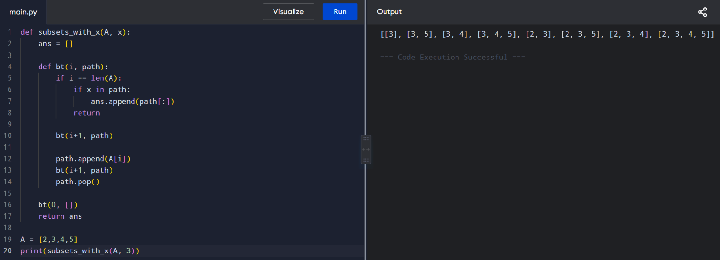
Time: O(2^N)
Space: O(N)

15. You are given two string arrays words1 and words2. A string b is a subset of string a if every letter in b occurs in a including multiplicity. For example, "wrr" is a subset of "warrior" but is not a subset of "world". A string a from words1 is universal if for every string b in words2, b is a subset of a. Return an array of all the universal strings in words1. You may return the answer in any order.
Aim
To find all words in words1 that contain all characters required by every word in words2.
Algorithm
- Find the maximum frequency of every character among words in words2.
- For each word in words1, count its characters.
- Check whether it satisfies all required frequencies.
- Add valid words to the result.
Python Program
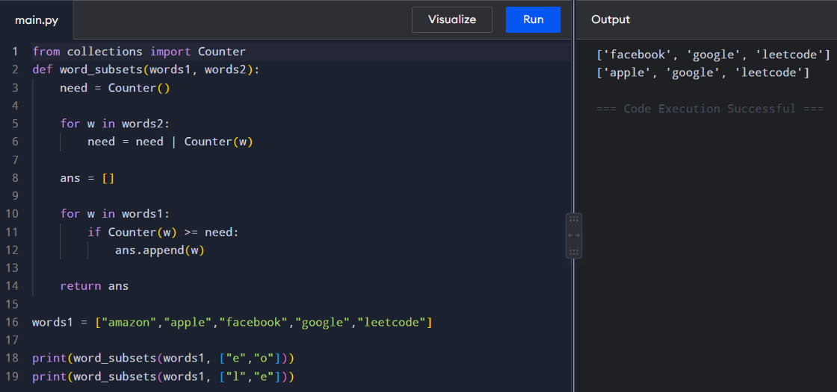
Time: O(M × L)
Space: O(26)

